1

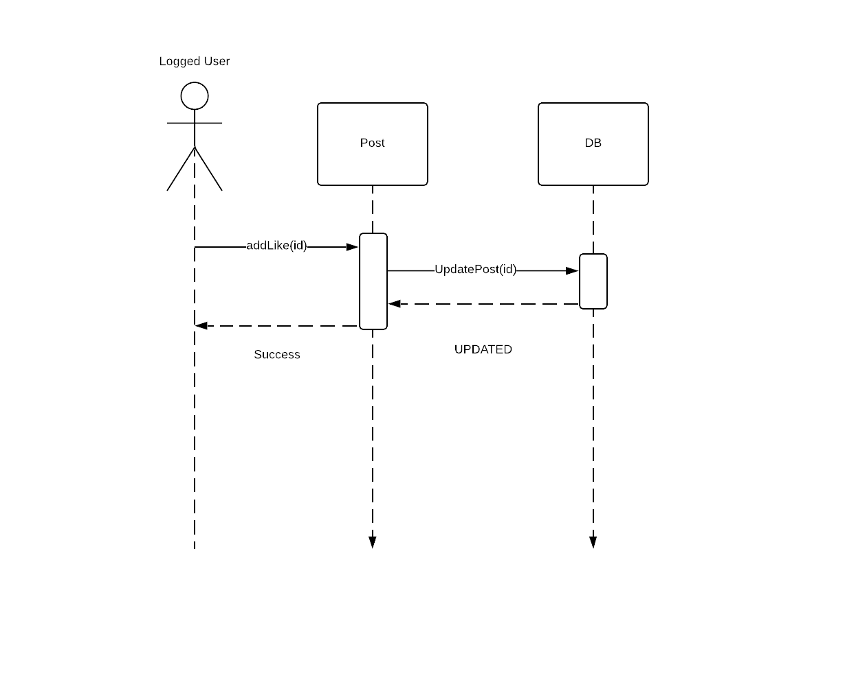

2

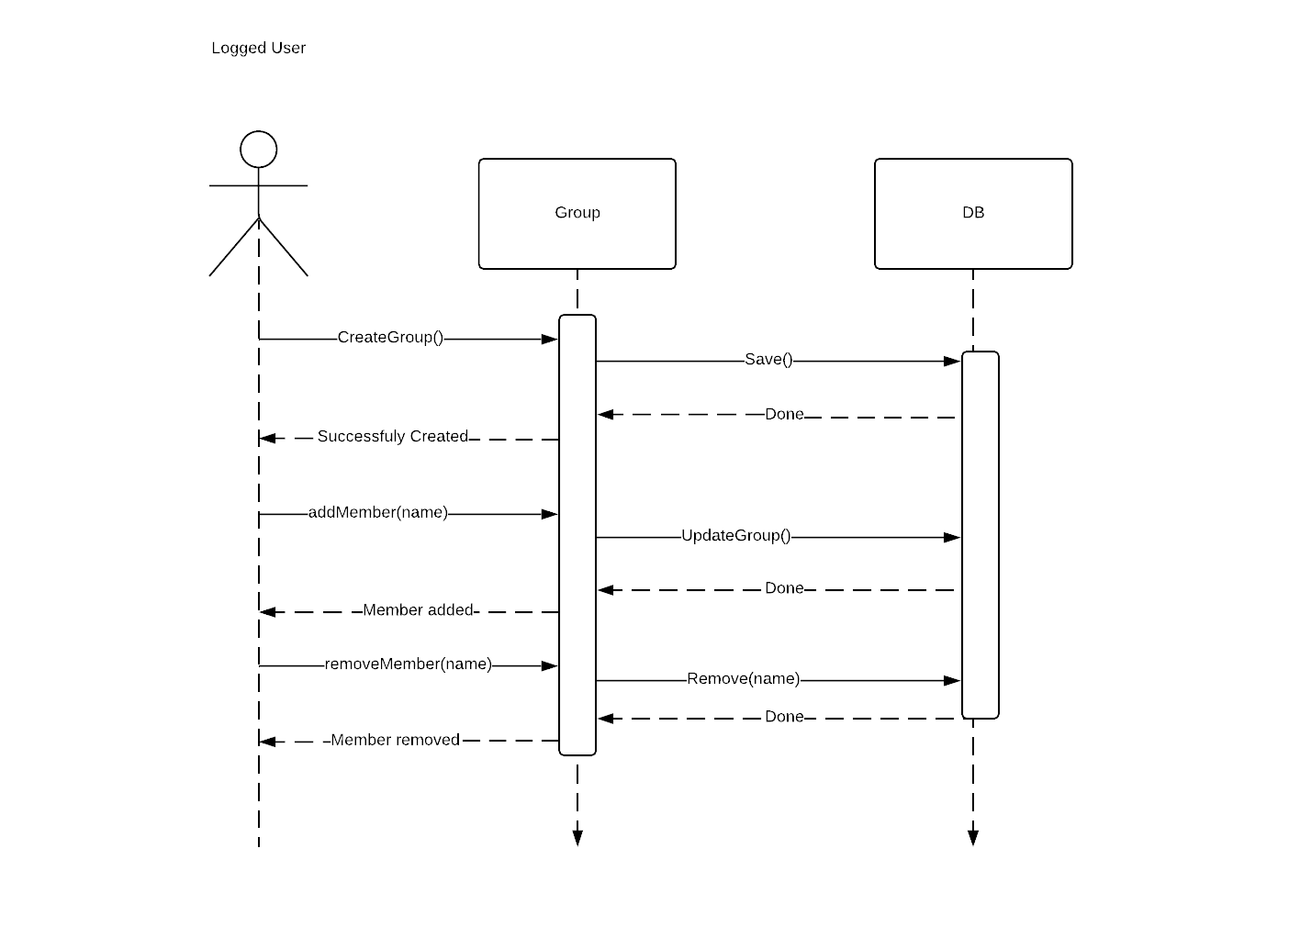

3

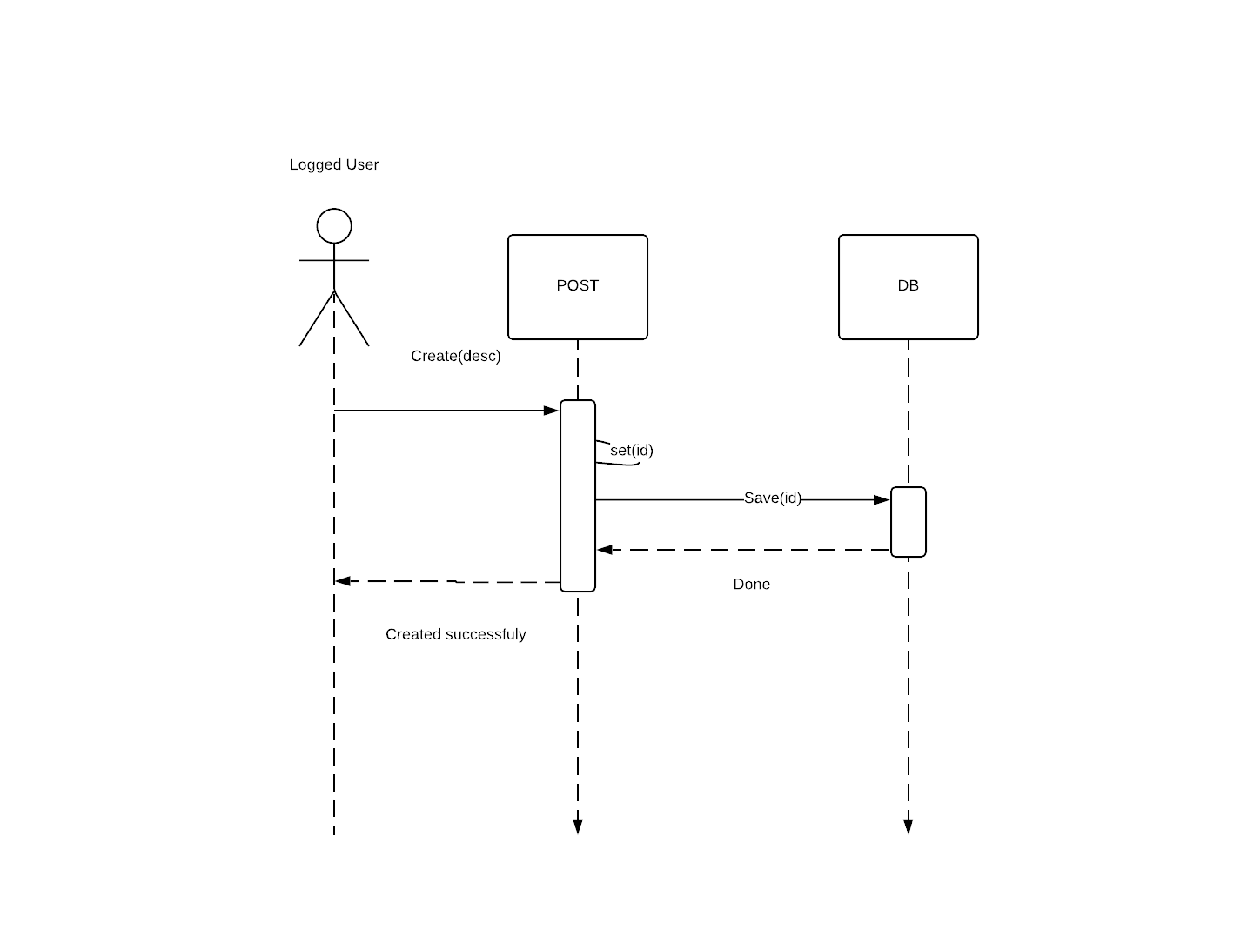

4

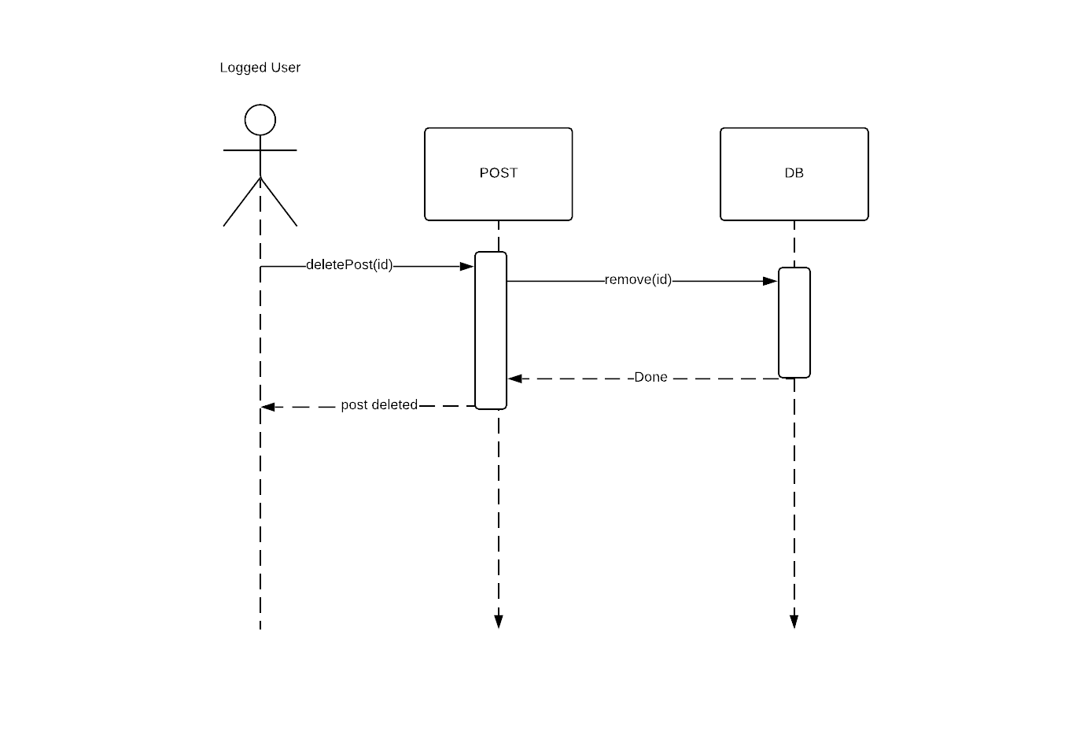

5

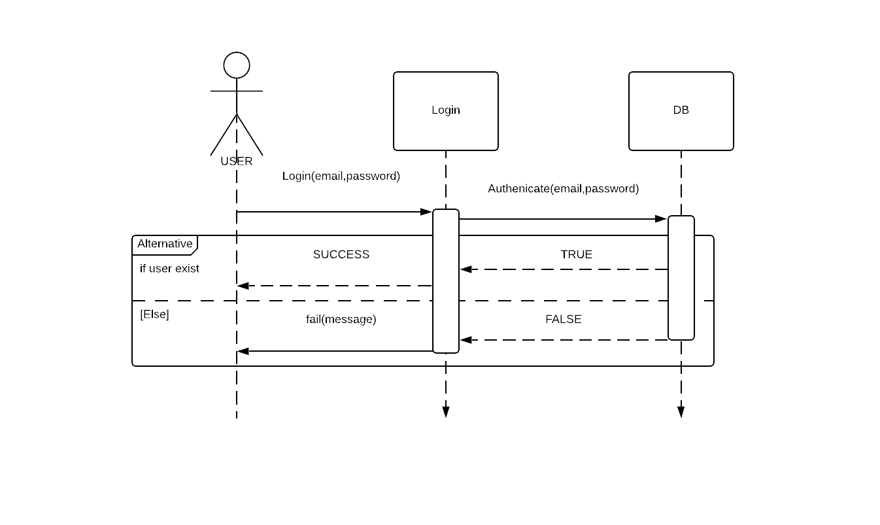

6

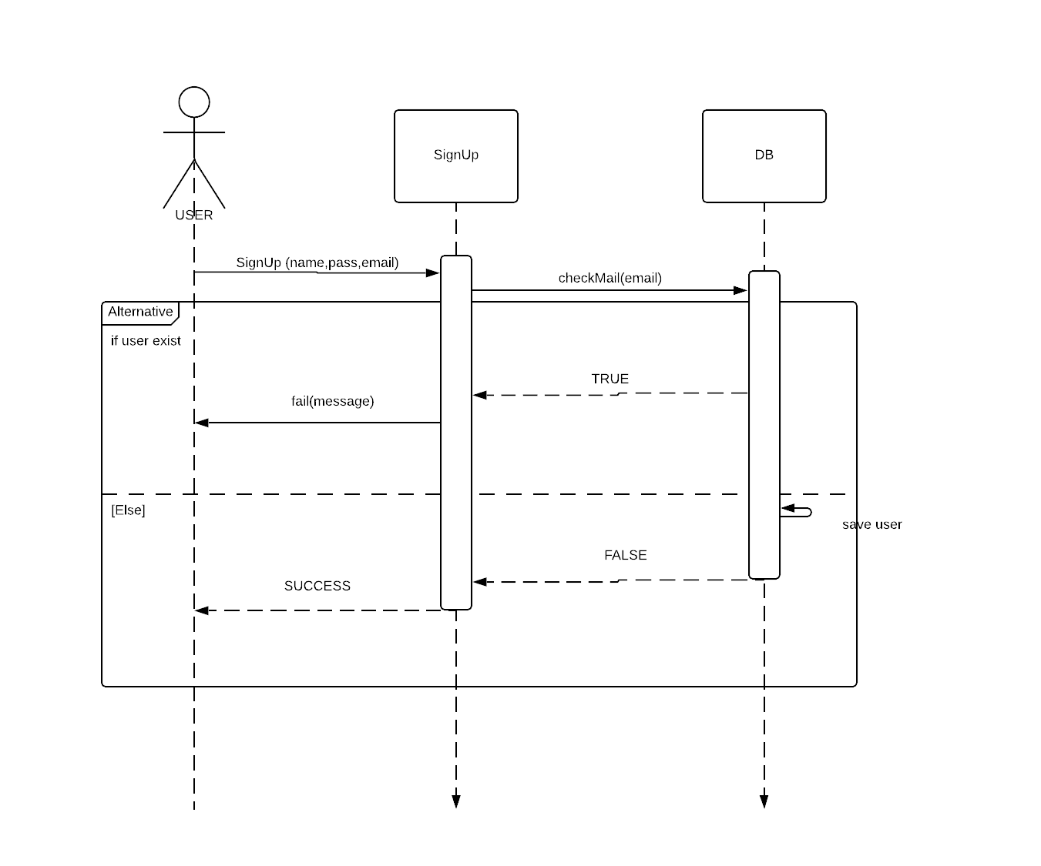

7

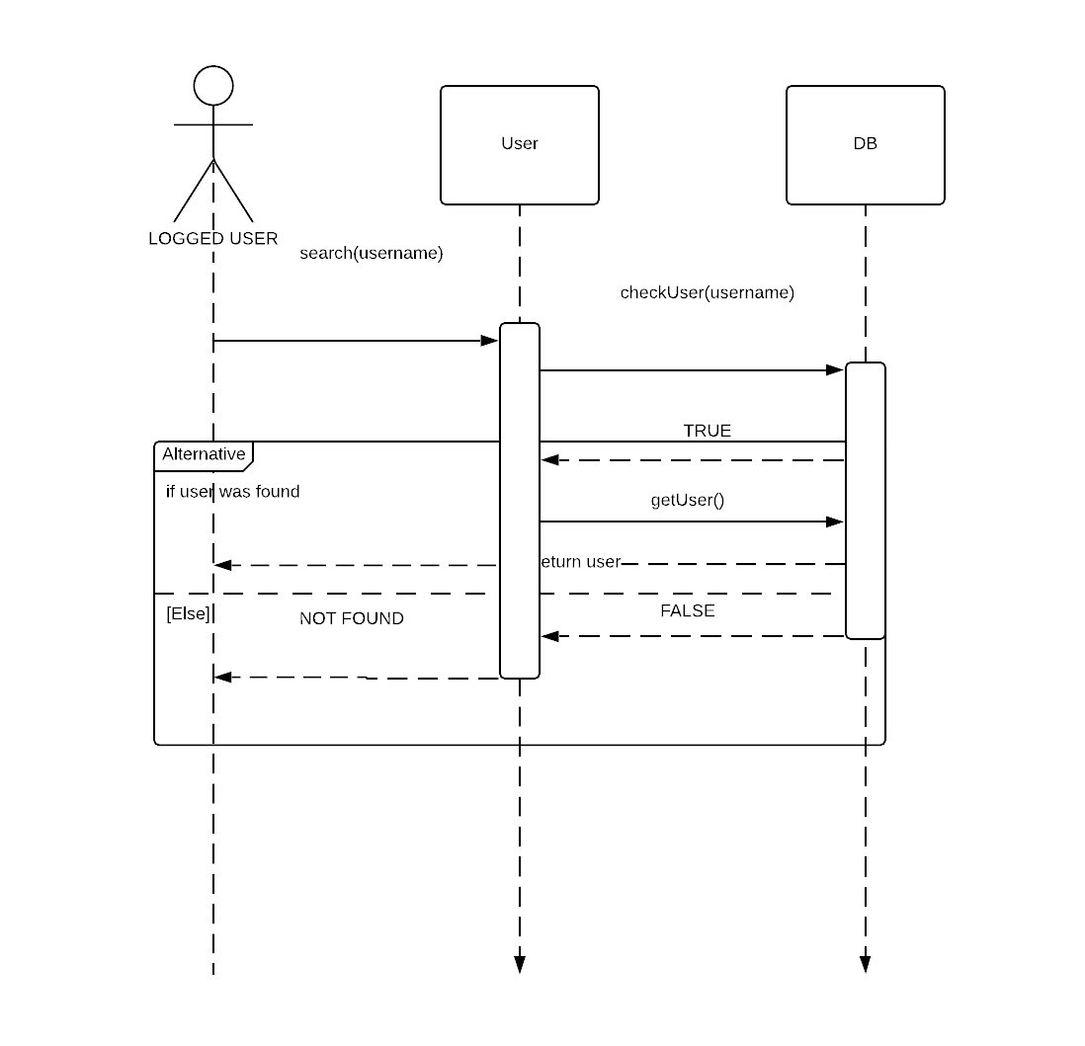

8

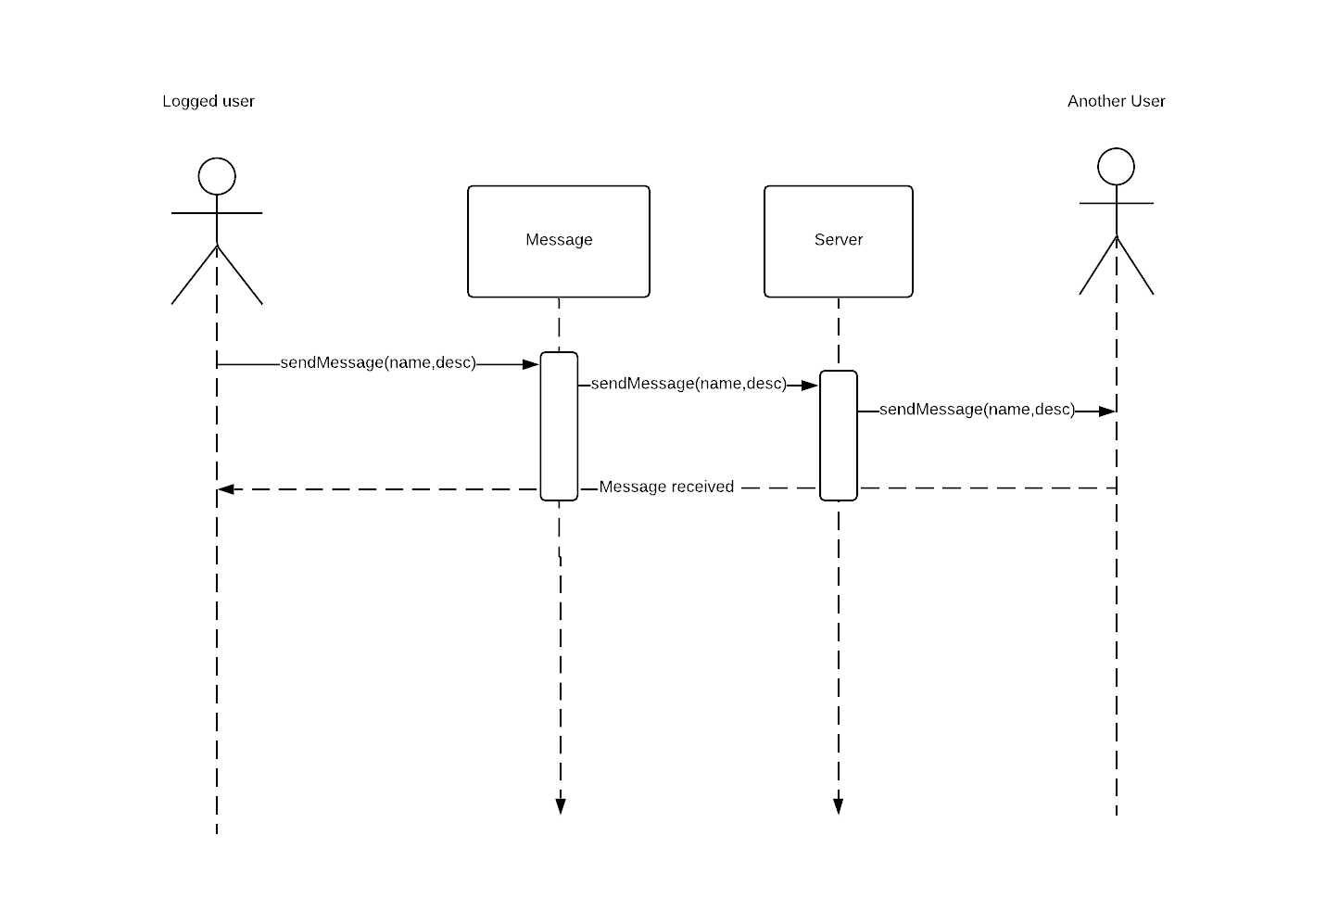

|  |  |  |
| --- | --- | --- |
| Class Name | Sequence Diagrams | Overall used methods |
| Post | 1,3,4 | Create,addLike,set,deletePost |
| Login | 5 | Login,fail |
| Signup | 6 | signUp,fail |
| Group | 2 | createGroup, addMember,  removeMember |
| Message | 8 | sendMessage |
| User | 7 | Search |